

A

**PROJECT REPORT ON**

“IMAGE SLIDER’’

Submitted to

**Department of Computer Science Engineering**

**Faculty of Engineering and Technology (co-education)**

**In partial fulfillment of first semester project**

Submitted by

MOHAMMED KAIF AKHTAR (USN: SG21CSE069)

MOHAMMED YASEEN (USN: SG21CSE072)

SHAIK SOHAIL (USN: SG21CSE509)

Under the guidance of

PROF. SHARANBASAPPA V H

CERTIFICATE

This is to certify that the project entitled “ **ANIME IMAGE SLIDER “**

**Is a bonafide work carried out by 1**)**MOHAMMED KAIF AKHTAR (USN: SG21CSE069,** **2) MOHAMMED YASEEN (USN : SG21CSE072), 3) SHAIK SOHAIL (USN : SG21CSE509) in partial fulfillment of B.**TECH first (1st)**Semester in Computer science engineering** of the faculty of engineering And technology (co-Education) **SHARNBASVA UNIVERSITY, kalaburagi during the year 2022-2023**. It is certified that she/he has completed the Project satisfactorily.

**MARKS DETAILS**

|  |  |  |  |
| --- | --- | --- | --- |
| **SI**  **NO** | NAME OF THE STUDENT | U S N | Marks  obtained |
| 1 | **MOHAMMED KAIF AKHTAR** | SG21CSE069 |  |
| 2 | **MOHAMMED YASEEN** | SG21CSE072 |  |
| 3 | **SHAIKH SOHAIL** | SG21CSE509 |  |

Guide Chairman Dean

Name Of The Examiners Signature with Date

ACKNOWLEDGEMENT

Any achievement does not depend solely on the individual efforts but also on the guidance, encouragement and co-operation of intellectual, elders and friends. A number of personalities, in their own capacities have helped us in carrying out his friends. A number of personalities, in their own capacities have helped us in carrying out this seminar work. I would like to take this opportunity to thank them all.

First of all, I would like to express our immense gratitude --------------------------------------, Registrar, Sharnbasva University, Kalaburagi for his help and inspiration during the tenure of the course.

I would like to express our immense gratitude to_______________________ Dean, Sharnbasva University, Kalaburagi for his help and inspiration during the tenure of the course.

I also extend my sincere thanks to ____________________ Chairman, Department of Computer science engineeringFaculty of Engineering & Technology (Co-Ed), Sharnbasva University, Kalaburagi for his constant encouragement.

I express my deep sense of gratitude to____________________________, as a guide for his valuable suggestions and encouragement. He is the one who provided me a dynamic intellectual and stimulating state of mind to work hard.

I also extend my sense of gratitude and sincere thanks to all the faculty members of Computer science engineeringdepartment , Sharnbasva University (Co-Ed), for their constant encouragement and support.

MOHAMMED KAIF AKHTAR (USN: SG21CSE069)

MOHAMMED YASEEN (USN: SG21CSE072)

SHAIK SOHAIL (USN: SG21CSE509)

**CONTENTS**

|  |  |  |
| --- | --- | --- |
| **SR.NO** | **PARTICULER** | **PAGE NO.** |
| **01.** | **INTRODUCTION** |  |
| **02.** | **IMPLEMENTATION** |  |
| **03.** | **RESULT** |  |
| **04.** | **CONCLUSION** |  |
| **05.** | **REFERENCE** |  |

**INTRODUCTION:-**

The **Hyper Text Markup Language** or **HTML** is the standard markup language for documents designed to be displayed in a web browser.

Web browser receive HTML documents from a web server or from local storage or render the documents into multimedia web pages. HTML describes the structure of a web page semantically and originally included cues for the appearance of the document.

HTML elements are the building blocks of HTML

Pages. With HTML constructs, images and other objects such as interactive forms may be embedded into the rendered page. HTML provides a means to create [structured documents](https://en.wikipedia.org/wiki/Structured_document) by denoting structural [semantics](https://en.wikipedia.org/wiki/Semantics) for text such as headings, paragraphs, lists, [links](https://en.wikipedia.org/wiki/Hyperlink), quotes and other items. HTML elements are delineated by *tags*, written using [angle brackets](https://en.wikipedia.org/wiki/Bracket#Angle_brackets). Tags such as <**img** /> and <**input** /> directly introduce content into the page. Other tags such as <**p**> surround and provide information about document text and may include other tags as sub-elements. Browsers do not display the HTML tags but use them to interpret the content of the page.

IMAGE SLIDER:-

# What Is An Image Slider?

An **Image Slider** is an animated WordPress design element used to display videos and images on a website. Like a slideshow, **Image Sliders** show one video or image at a time. The content changes when visitors click to see the next slide, or it changes automatically after a few seconds.

## When to Use an Image Slider?

Freelancer or business sites often use sliders to showcase their most important work or portfolio in an eye-catching, attention-grabbing way. Sliders come with arrows, thumbnails, or buttons to allow visitors to see a specific image or control what they see. The aim is to engage them with targeted content, like promoting a unique offering, so that they stay on a page longer than average.

If you don’t use sliders for a specific purpose, you can annoy visitors, lower conversion rates, and cause “banner blindness,” where viewers see a spam-looking ad. To avoid this, consider using image sliders to:

* Display news updates
* Make unique content stand out
* Help visitors quickly choose options
* Display photo galleries
* Present professional portfolios
* Showcase current eCommerce sales

**IMPLEMENTATION:-**

Visual Studio Code is a streamlined code editor with support for development operations like debugging, task running, and version control. It aims to provide just the tools a developer needs for a quick code-build-debug cycle and leaves more complex workflows to fuller featured IDEs.

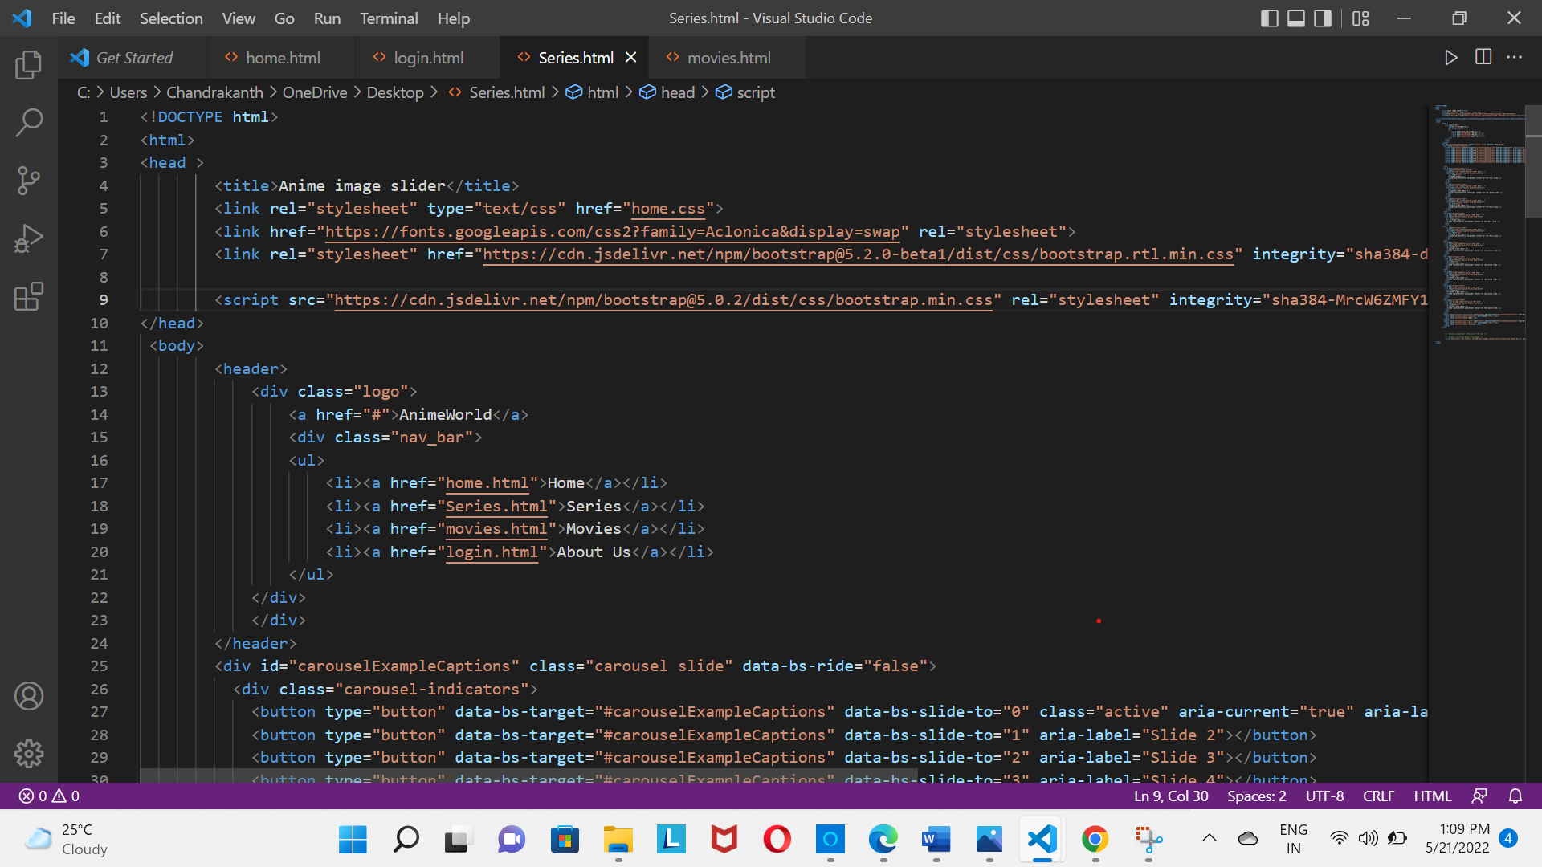

TAGS USED

* Html **(<html>…</html>)**
* Head tag **(<head>…</head>)**
* Title tag **(<title>…</title>)**
* Body tag **(<body>…</body>**)
* Heading tag **(<h1> … </h1>)**
* Paragraph **(<p>…</p>)**
* Link tag (**<a> … </a>**)
* Image tag **(<img>)**
* Divide tag (**<div> … </div>**)
* Span tag (**<span> … </span>**)

## **1. <html> … </html> — The root element**

All web pages start with the html element. It’s also called the root element because it’s at the root of the tree of elements that make up a web page.

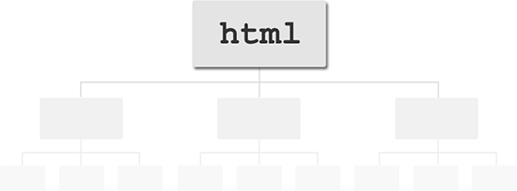The html element sits at the root of the tree of elements in a web page.

To create the html element, you write an opening <html> tag followed by a closing </html> tag. Everything else in your web page then goes between these 2 tags:

<html>

(all other page elements go here)

</html>

## **2. <head> … </head> — The document head**

The head element contains information about the web page, as opposed to the web page content itself. There are many elements that you can put inside the head element, such as:

* title (described below)
* link, which you can use to add style sheets and favicons to your page
* meta, for specifying things like character sets, page descriptions, and keywords for search engines
* script, for adding JavaScript code to the page

Here’s a typical head element:

<head>

<title>The Adventures of My Cat Lucky</title>

<meta http-equiv="Content-Type" content="text/html; charset=utf-8">

<meta name="description" content="The adventures of my favourite pet cat Lucky, with stories, pictures and movies.">

<meta name="keywords" content="cat,Lucky,pet,animal">

<link rel="stylesheet" type="text/css" href="/style.css">

<link rel="shortcut icon" href="/favicon.ico">

</head>

## **3. <title> … </title> — The page title**

The title element contains the title of the page. The title is displayed in the browser’s title bar (the bar at the top of the browser window), as well as in bookmarks, search engine results, and many other places.

The title should describe the page’s content succinctly and accurately. Try to give each page of your site its own unique title.

Here’s an example:

<title>The Adventures of My Cat Lucky</title>

## 4. **<body> … </body> — The page’s content**

The body element appears after the head element in the page. It should contain all the content of your web page: text, images, and so on. All web pages have 1 single body element, with the exception of frameset pages, which contain frame elements instead.

Here’s the general format of the body element:

<body>

(all page content goes here)

</body>

## **5. <h1> … </h1> — A section heading**

Headings let you break up your page content into readable chunks. They work much like headings and subheadings in a book or a report.

HTML actually supports 6 heading elements: h1, h2, h3, h4, h5, and h6. h1 is for the most important headings, h2 is for less important subheadings, and so on. Typically you won’t need to use more than h1, h2 and h3, unless your page is very long and complex.

Here’s an example of an h1 heading element:

<h1>The Adventures of My Cat Lucky</h1>

## **6. <p> … </p> — A paragraph**

The p element lets you create paragraphs of text. Most browsers display paragraphs with a vertical gap between each paragraph, nicely breaking up the text.

While you can create “paragraphs” of text just by using <br> tags to insert blank lines between chunks of text, it’s better to use p elements instead. Not only is it neater, but it gives browsers, search engines and other non-humans a better idea of how your page is structured.

Here’s an example of a paragraph:

<p>My cat Lucky has a lot of adventures. Yesterday she caught a mouse, and this morning she caught two!</p>

A good rule of thumb when writing text for the web is to make sure that each paragraph contains a single point, topic or thought. If you want to talk about 2 different things, use 2 paragraphs.

## **7. <a> … </a> — A link**

One of the most important elements in a web page, the a element lets you create links to other content. The content can be either on your own site or on another site.

To create a link, you wrap <a> and </a> tags around the content you want to use for the link, and supply the URL to link to in the <a> tag’s href attribute.

Here’s how to create some text that links to www.example.com:

<a href="http://www.example.com/">Visit this great website!</a>

## **8. <img> — An image**

The img element lets you insert images into your web pages. To insert an image, you first upload the image to your web server, then use an <img> tag to reference the uploaded image filename. Here’s an example:

<img src="myphoto.jpg" alt="My Photo">

The alt attribute is required for all img tags. It’s used by browsers that don’t display images to give alternative text to the visitor.

Find out more about [using images in web pages](https://www.elated.com/articles/html-images/).

## **9. <div> … </div> — A block-level container for content**

The div element is a generic container that you can use to add more structure to your page content. For example, you might group several paragraphs or headings that serve a similar purpose together inside a div element. Typically, div elements are used for things like:

* Page headers and footers
* Columns of content and sidebars
* Highlighted boxes within the text flow
* Areas of the page with a specific purpose, such as ad spots
* Image galleries

By adding class and/or id attributes to your div elements, you can then use [CSS](https://www.elated.com/articles/cat/css/) to style and position the divs. This is the basis for creating CSS-based page layouts.

Here’s an example that uses a div to contain the content for a sidebar in the page:

<div id="sidebar">

<h1>Sidebar Heading</h1>

<p>Sidebar text</p>

<p>More sidebar text</p>

</div>

## **10. <span> … </span> — An inline container for content**

The span element is similar to div in that it’s used to add structure to your content. The difference is that div is a block-level element, while span is an inline element:

* **Block-level elements**, such as div, h1, and p, are elements that are designed to hold relatively large or stand-alone blocks of content, such as paragraphs of text. A block-level element always starts on a new line.
* **Inline elements**, such as span, a, and img, are designed to hold smaller pieces of content — such as a few words or a sentence — within a larger block of content. Adding an inline element doesn’t cause a new line to be created. Block-level elements can contain inline elements, but inline elements can’t contain block-level elements.

As with a div, you often add a class and/or id attribute to a span so that you can style it using CSS.

The following example uses span elements to indicate product names within a paragraph. These product names could then be highlighted using CSS. A custom search engine could also potentially use the information provided by the span elements to identify the products within the page.

<p>Some of our products include <span class="product">SuperWidgets</span>, <span class="product">MegaWidgets</span>, and <span class="product">WonderWidgets</span>.</p>

RESULT





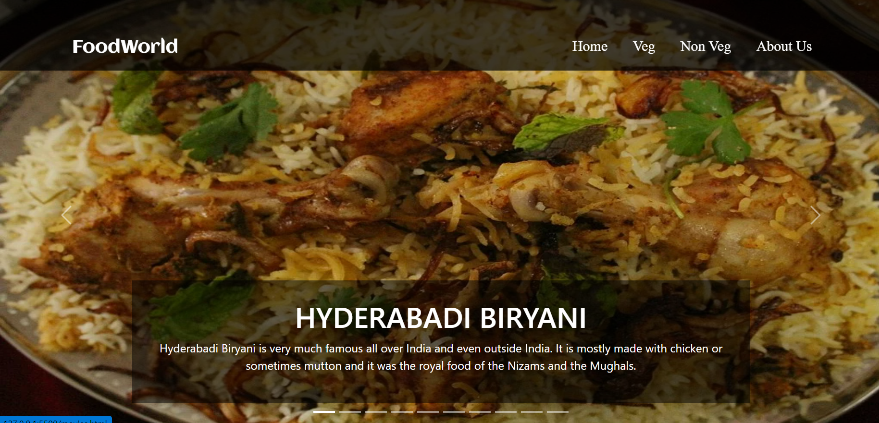

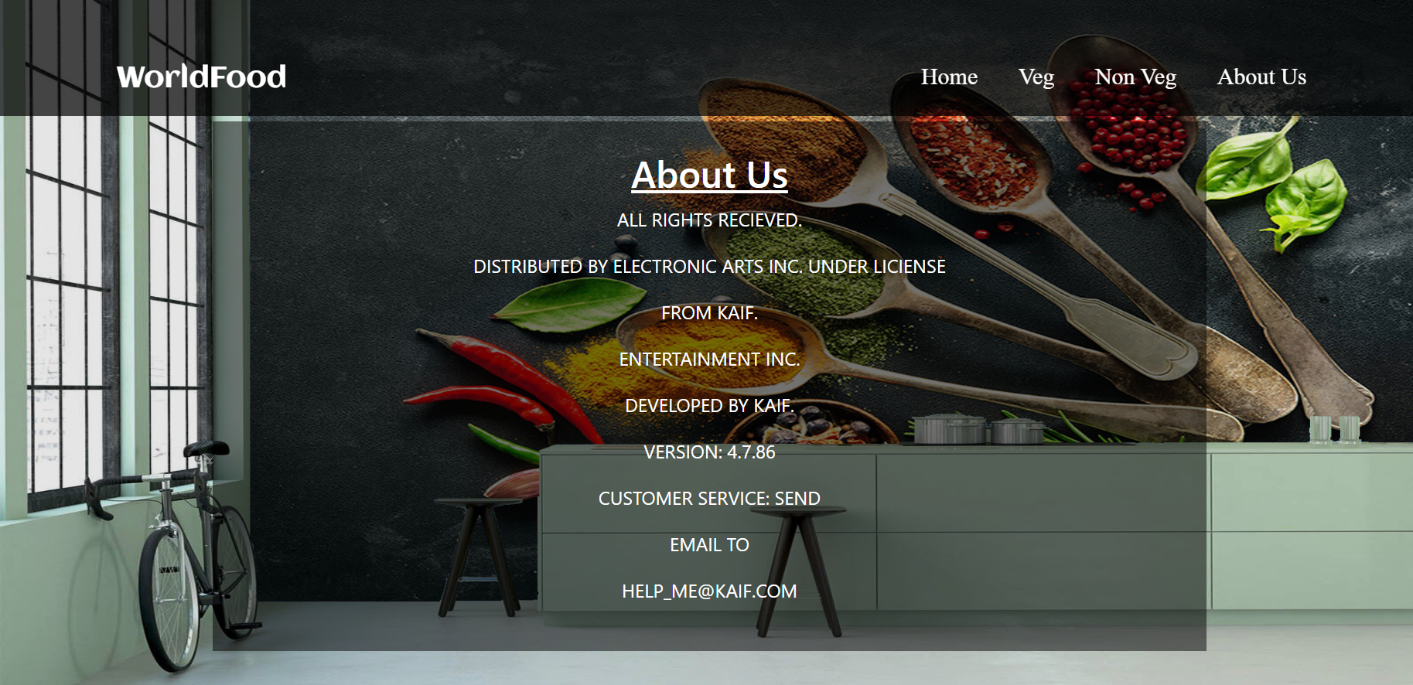

**CONCLUSION**

* **They save space:** Consolidate content so more is visible on one screen.
* **Users stay engaged:** Visitors linger in one place to view content, and visuals provide a break before continuing down the page.
* **Sliders consolidate images:** While media on the page can draw attention away from text, sliders put it all in one place to prevent distractions.
* **Users control content:** Always allow users to proceed through sliders at their own pace or skip them altogether if that’s not what they are looking for.

**REFERENCE**

1. [**www.google.com**](http://www.google.com)
2. [**www.w3school.com**](http://www.w3school.com)
3. [**www.bootstrap.com**](http://www.bootstrap.com)